**DEPARTMENT OF COMPUTER & SOFTWARE ENGINEERING**

**COLLEGE OF E&ME, NUST, RAWALPINDI**

AI & Decision Support Systems

Lab Report #1

**Student Name: Nawab Aarij Imam**

**Degree/ Syndicate: 43 CE - A**

**Task1:**

**Q1: Write a program that lets the user enter in some English text, then converts the text to Pig-Latin.**

To review, Pig-Latin takes the first letter of a word, puts it at the end, and appends “ay”. The only exception is if the first letter is a vowel, in which case we keep it as it is and append “hay” to the end.

E.g. “hello” -> “ellohay”, and “image” -> “imagehay”

***Hint:*** *Split the entered string through split() method and then iterate over the resultant list, e.g. “My name is John Smith”.split(“ ”) -> [“My”, “name”, “is”, “John”, “Smith”]*

**Code:**

import numpy as np

def pig_latin(text):

# check whitespace

vowels = ['A','E','I','O','U','a','e','i','o','u']

word_array = text.split(" ")

for i, word in enumerate(word_array):

if word[0] in vowels:

word_array[i] = word + 'hay'

else:

word_array[i] = word[1:] + word[0] + 'ay'

return ' '.join(word_array)

if __name__ == '__main__':

input_string = input("Enter a string: ")

print(pig_latin(input_string))

**Output:**

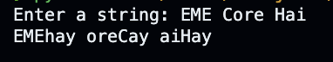

**Task2:**

**Q2: Write a method to calculate Fibonacci series up to ‘n’ points. After calculating the series, the method should return it to main.**

**Code:**

import numpy as np

def fibonacci(n):

series = [0,1]

for i in range(n)[1:]:

series.append(series[i-1] + series[i])

return series

if __name__ == '__main__':

print(fibonacci(10))

**Output:**



**Task3:**

**Q3: Write a simple program that builds a random password generator. For password generator the user must enter total number of passwords and their lengths. Display all the passwords with random characters.**

**Code:**

import random

import string

def generate_password(length):

characters = string.ascii_letters + string.punctuation + string.digits

password = ''.join(random.choice(characters) for i in range(length))

return password

if __name__ == '__main__':

total_passwords = int(input('Enter number of passwords: '))

length = int(input('Enter length of passwords: '))

passwords = []

for i in range(total_passwords):

passwords.append(generate_password(length))

print(f'Your passwords are: ')

for i, pw in enumerate(passwords):

print(f' {i+1}. {pw}')

**Output:**

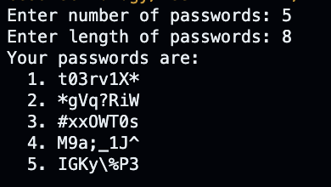

**Task4:**

**Q4: Create a class named ‘Complex’ that must have the following attributes:**

**Variables named ‘Real’ and ‘Imaginary’**

**Methods named Magnitude () and Orientation ()**

**Take a complex number from user in main and print its magnitude and orientation. You have a liberty to create methods signature as you like.**

**Code:**

import math

class Complex:

def __init__(self,real,img):

self.real = real

self.img = img

def mag(self):

return math.sqrt(self.real ** 2 + self.img ** 2)

def orient(self):

return math.atan(self.img / self.real)

if __name__ == '__main__':

num1 = Complex(3,5)

print(num1.mag())

print(num1.orient())

**Output:**

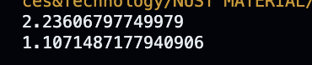

**Task5:**

**Q5: Create the following Binary Search Tree and search for the node ‘13’. You can hard code the tree as well, but it is better if you create it dynamically at run time (You must have learned in Data Structures & Algorithms). Also, tell the time performance of searching the node ‘13’ in Big-O notation.**

**Code:**

class Node:

def __init__(self, key):

self.left = None

self.right = None

self.value = key

class BinarySearchTree:

def __init__(self):

self.root = None

def insert(self, key):

if self.root is None:

self.root = Node(key)

else:

self._insert(self.root, key)

def _insert(self, current_node, key):

if key < current_node.value:

if current_node.left is None:

current_node.left = Node(key)

else:

self._insert(current_node.left, key)

elif key > current_node.value:

if current_node.right is None:

current_node.right = Node(key)

else:

self._insert(current_node.right, key)

def search(self, key):

return self._search(self.root, key)

def _search(self, current_node, key):

if current_node is None:

return False

if key == current_node.value:

return True

elif key < current_node.value:

return self._search(current_node.left, key)

else:

return self._search(current_node.right, key)

bst = BinarySearchTree()

bst.insert(51)

bst.insert(13)

bst.insert(20)

bst.insert(43)

bst.insert(70)

bst.insert(67)

bst.insert(80)

print(bst.search(13))

**Output:**

